

**T.C. Maltepe University**

**Faculty of Engineering& Natural Sciences**

**Software EngineeringDepartment**

**SE 315 SOFTWARE ENGINEERING PROJECT REPORT**

**SudOG**

**Project Participant:**

**Ömer GÖKDERE 110706008**

**Project Advisor:**

**Yrd.Doç. Dr. Ayşe SALMAN**

**ISTANBUL, 2016**

**ABSTRACT**

SudOG is a puzzle game by numbers.

Sudoku is is a logic-based,combinatorialnumber-placement puzzle game. The objective is to fill a 9×9 grid with digits so that each column, each row, and each of the nine 3×3 sub-grids that compose the grid contains all of the digits from 1 to 9.

SudOG, application is named of sudoku game and the initials of the coder who is Omer Gokdere.

**INTRODUCTION**

* SudOG application will be used as a puzzle game.
* It will be available for everyone who wants to use it.
* It will be commonly used by gamers to solve it
* Users can play the game with 3 type of difficulty which are easy – medium- hard mod.
* Application can be accessible from Android operating system.

**PROJECT REQUIREMENTS**

**CUSTOMER MEETINGS**

According to customer meetings ; client need an application for people who wants to play Sudoku (puzzle game).Another hand , customer required that the game has 3 type of difficulty select which are easy-medium and hard mode.Also customer wants that application save the games that is not finished , and user can go on the game by loading whenever needed.Other customer requirement is a timer that calculated the time during play the game.

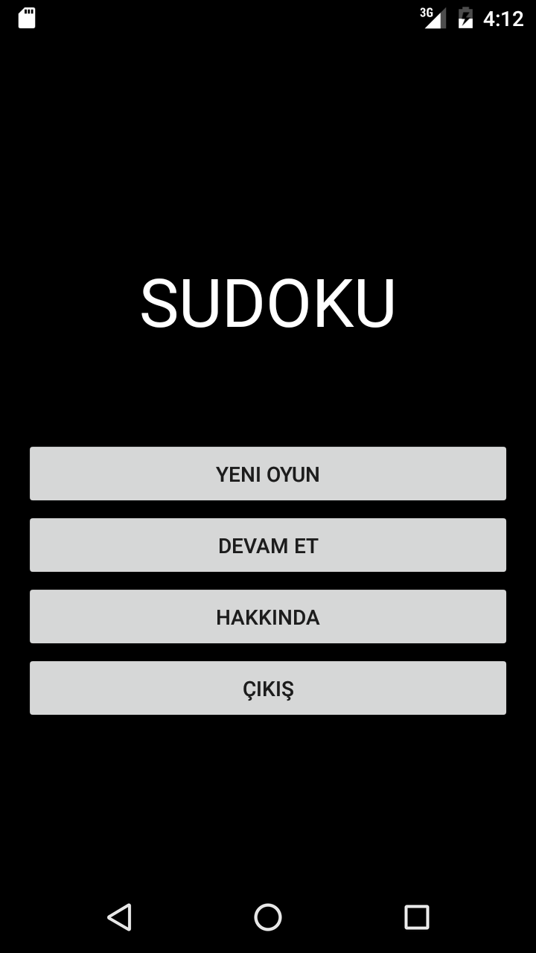 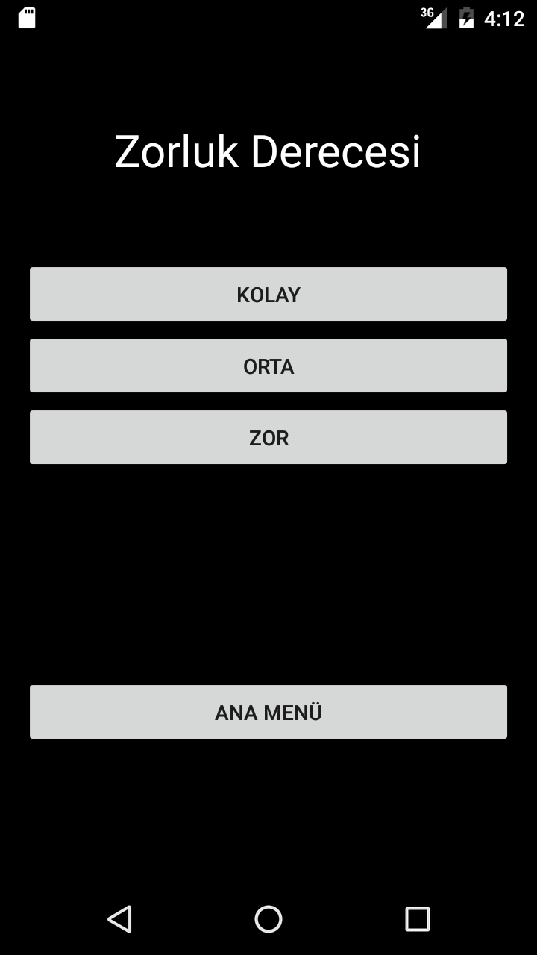

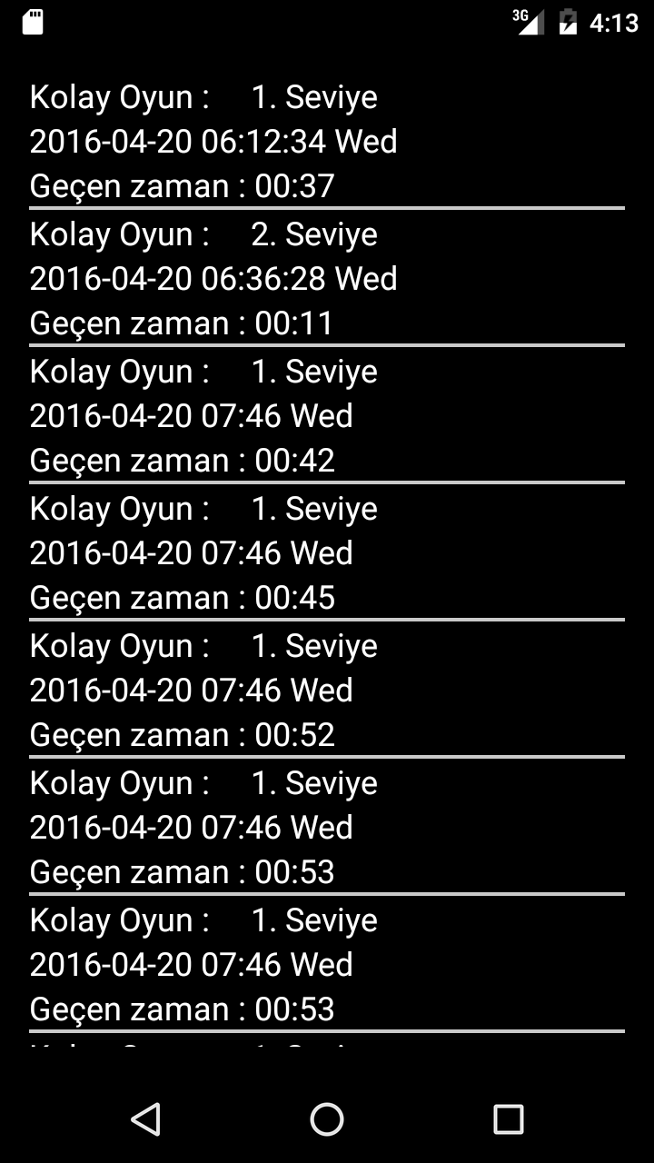 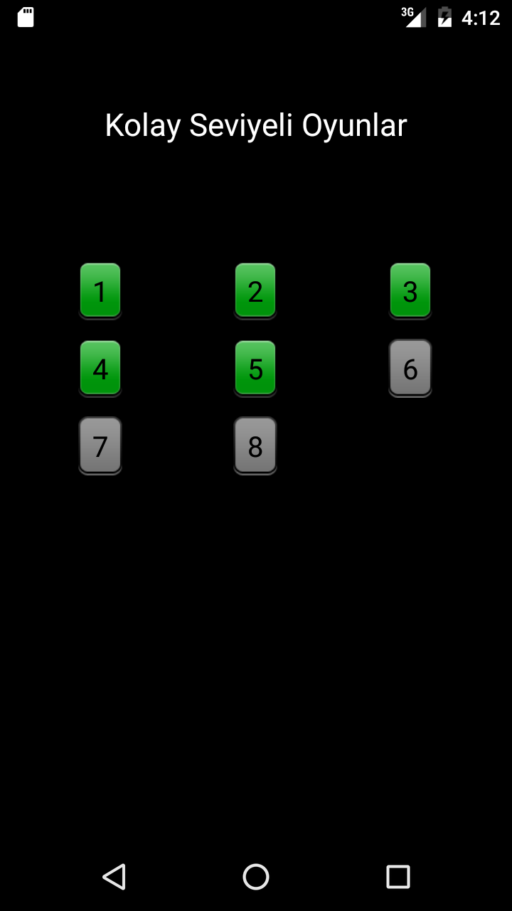 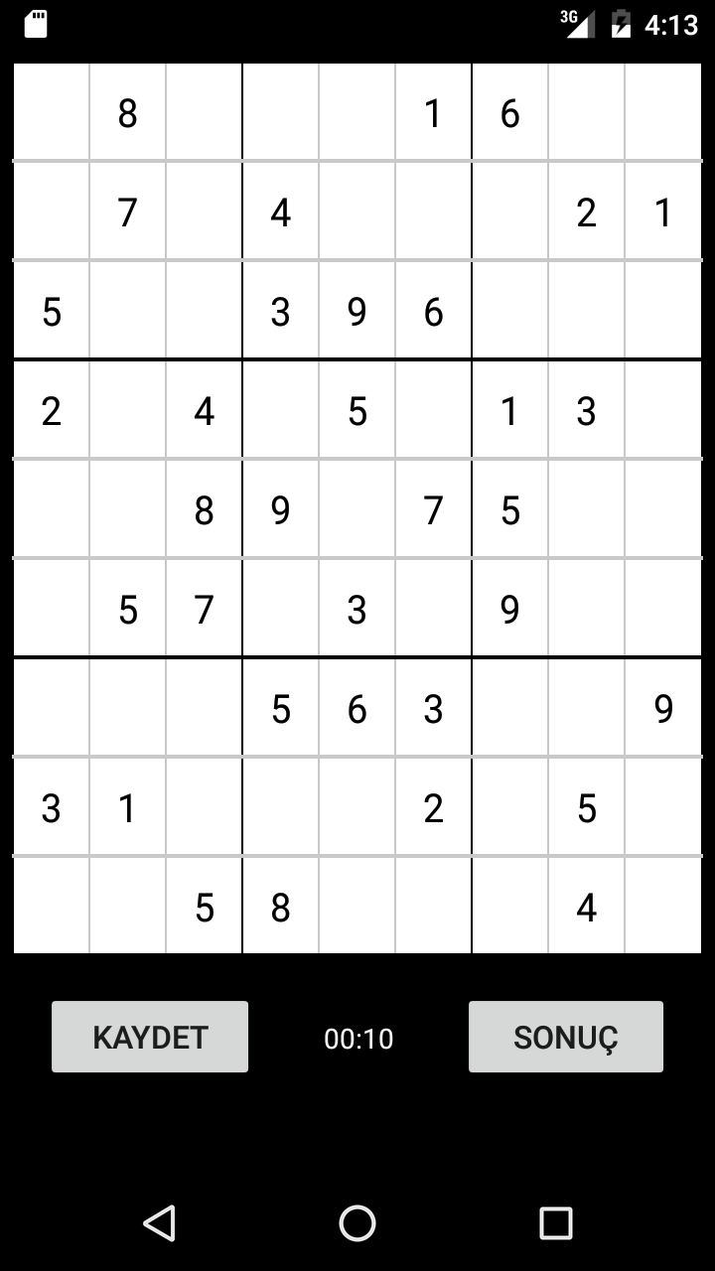 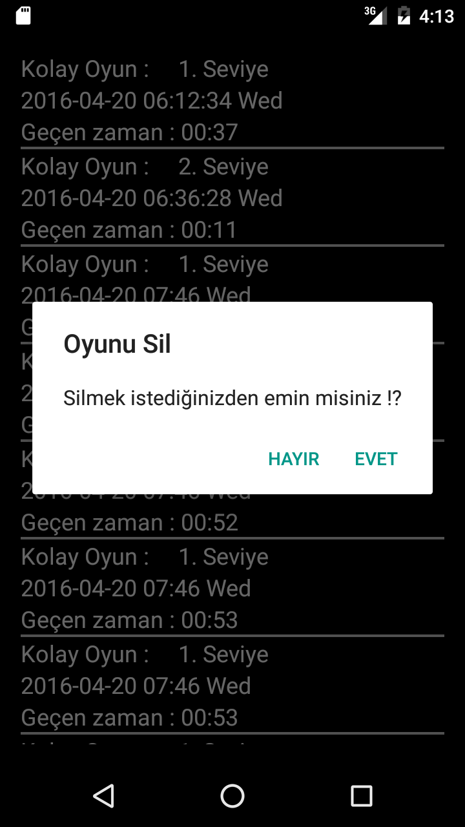

**REQUIREMENTS**

**Functional Requirements**

Functional requirements of the software to be developed are listed here.

* Main page of application is a menu that user select what do user wants to do.
* New Game buton allows users to create new game and it provide user to difficulty screen of the application
* Continue button allows users to load old game to go on it.
* User can check the information of an application and game by clicking About button.
* User can exit from game by clicking Exit button
* User can add numbers through puzzle board by clicking on the place that where user wants to add a new number.
* User can save game and load game .
* User can see all the results by clicking SHOW RESULT buton.
* User can trace the time on puzzle board.

**Non-Functional Requirements**

Non-functional requirements of the software to be developed are listed here.

* The system will run on android environment.
* The response time of the system must be less than2 seconds.
* When the users clicked somewhere its can cause error or empty game will be monitored some error messages to directing user.
* Application has user friendly design who wants to use this application easily.
* The system to be developed shoul provide ease of use which are the current mobile devices already provide users such as multi-touch , slide properties and the visual elements with the Professional level.
* Background and text colors selected carefully not to reduce the readability.
* Ease of uses and the general habbits of usage Home / Back buttons on the device will be protected

**VALIDATIONS**

* System can work as game ? : Yes , it Works as user required.
* Timer is added to check how long does game takes ? : Yes user can check how long does game takes while playing SudOG at the center of bottom side.
* Save button is added to save game for playing later ? : Yes , save button is saving game while you play.
* User can see all the correct answers by clicking the buton on puzzle board activity. ? : Yes , user can see the results of puzzle game while playing .
* System automatically adds the time and date saved games and show it on loading activity. ? : Yes, after you saved game , loading game activity shows saved games by date and time informations.
* Three type of difficulty has been added which are easy , medium and hard modes ? : Three type of difficulties are working , also user cannot go further levels before complete one previous.

**VERIFICATIONS**

* System can work as game
* Timer is added to check how long does game takes.
* Save button is added to save game for playing later.
* Loading game activity has been added to load previous games as saved .
* Informations about the game can be accessible on main activity by about button.
* Three type of difficulty has been added which are easy , medium and hard modes
* System automatically adds the time and date saved games and show it on loading activity.
* User can see all the correct answers by clicking the buton on puzzle board activity.

**USE-CASE MODEL**

**Use-Cases and Actors**

SudOG application consist of an actor who is "user".

User is a person who can play game.

1. User can start a new game by choosing difficulty level as “Easy” then play.
2. User can start a new game by choosing difficulty level as “Medium” then play.
3. User can start a new game by choosing difficulty level as “Hard” then play.
4. User can load the game which is already started and saved.

**Use-Case Diagram**

sudog-use-case-diagram.png

**Sequence Diagram**

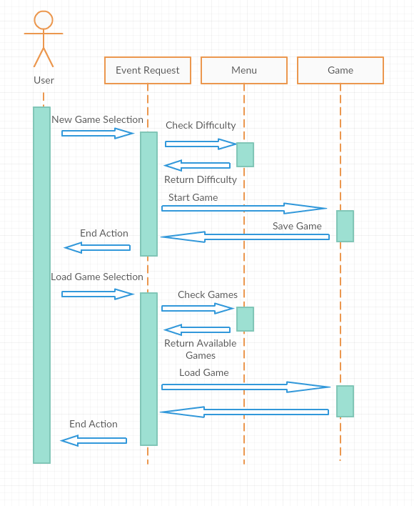

**UML Class Diagram**

